Project Design Phase-II
Data Flow Diagram & User Stories

Date | 04 February 2026
Team ID | LTVIP2026TMIDS66241
Project Name | Civil Engineering Inisght studio
Maximum Marks | 4 Marks

Data Flow Diagrams:
A Data Flow Diagram (DFD) is a traditional visual representation of the information flows within a system. A neat and clear DFD can depict the right amount of the system requirement graphically. It shows how data enters and leaves the system, what changes the information, and where data is stored.

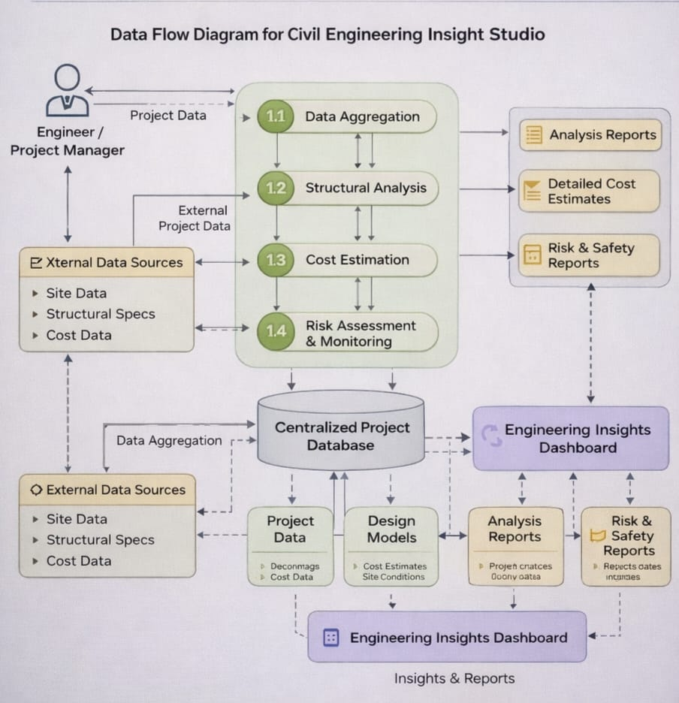

User Stories
Use the below template to list all the user stories for the product.
User Type | Functional Requirement (Epic) | User Story Number | User Story / Task | Acceptance criteria | Priority | Release
Student/Engineer | User Interface Setup | USN-1 | As a user, I can access a Streamlit-based interface to enter a project details. | I can access my dashboard | High | Sprint-1
Administrator | Input Validation | USN-2 | As a user, I want the application to validate my inputs. | I can validate the inputs | High | Sprint-1
System | AI Model Integration | USN-3 | As a user, I want the system to calculate load stress, and material estiamtion using integrated engineering. | I can calculate model | High | Sprint-2
Administrator | Material Estimation & Cost Analysis | USN-4 | As a user, I want to generate a cost estimation reports for construction projects. | I can generate a reports for user interaction | Medium | Sprint-2
Student/Engineer | Output Display | USN-5 | As a user, I want to view graphs and charts representing structural strength, cost and project progress. | I can see the output of graph generated | High | Sprint-3
Deployment Team | Deployment | USN-6 | As a user, I want the application to be deployed and accessible through the internet. | I can deploy in the system | Medium | Sprint-3

